## Dokumentation Gameplay

In general, the game provides basic functionality as outlined in the source document for the purposes of the interview process.

The game is played from the player's perspective, set at the playable level. You can access the level from the main menu, which is visible at the start of the game. To begin gameplay, the player must press a red button on a pedestal located in front of them within the game environment. Once the button is pressed, items are spawned around the map, which the player needs to collect. Collecting the final item concludes the round and saves the time of the last completed round. This time is displayed in the pause menu, which can be accessed using the 'P' or 'Esc' keys.

All collected items are stored in the inventory, where the player can either exchange them for score or drop them on the ground. Dropped items will not be counted in subsequent rounds.

A round can also end if the player loses all their life points. Life is lost when standing too close to trees with dark purple leaves and can be restored by standing near trees with golden leaves. The damage and healing rates are set at 2 points per second, with the default life total being 100 points. If the player loses all their life points, an end screen is displayed, offering options to restart the level, return to the main menu, or quit the game.

## Dokumentation UI

The user interface consists of 7 widgets and 1 animation.

**Main menu** uses 2 widgets:

1. Main Menu Widget (WB_MainMenu)

The first widget shows on screen after the startup of game. Main menu text and buttons are placed within vertical box and anchored in the center of screen.

The ‘Start New Game’ button opens playable level. The ‘Settings’ button creates a Settings widget that is overlayed over Main Menu screen. The ‘Quit’ Game button closes the game.

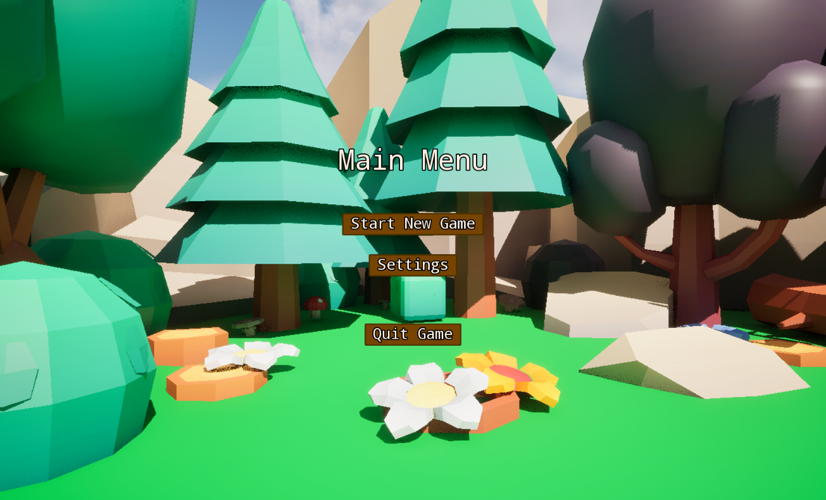

*Picture 1 Showcase of the Main menu screen*

2. Settings Widget (WB_Settings)

Settings screen consists of settings text and three available settings, which are placed within scroll box and are anchored on the left center of the screen.

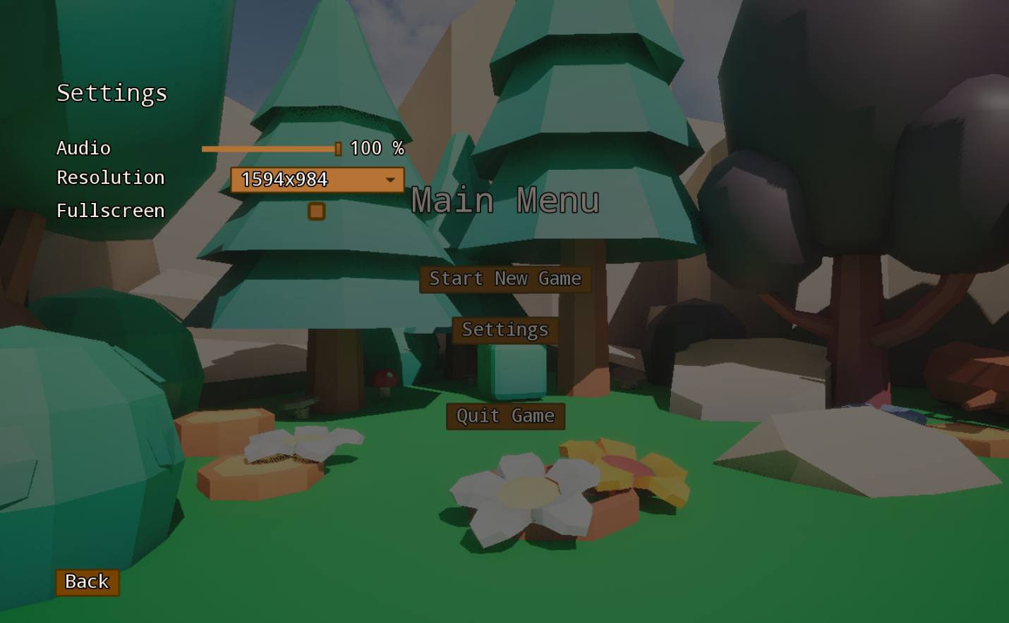

*Picture 2 Showcase of the Settings menu*

Back button (on the bottom-left corner of the screen) has functionality that removes Settings widget (in the background) and on the frontend serves for returning to menu.

**Playable level** uses 5 widgets:  
 1. HUD Widget (WB_HUD)

The text showing time of the current game round is anchored in the top-middle of screen. Bothe the game round and timer start once the button in level is pressed.

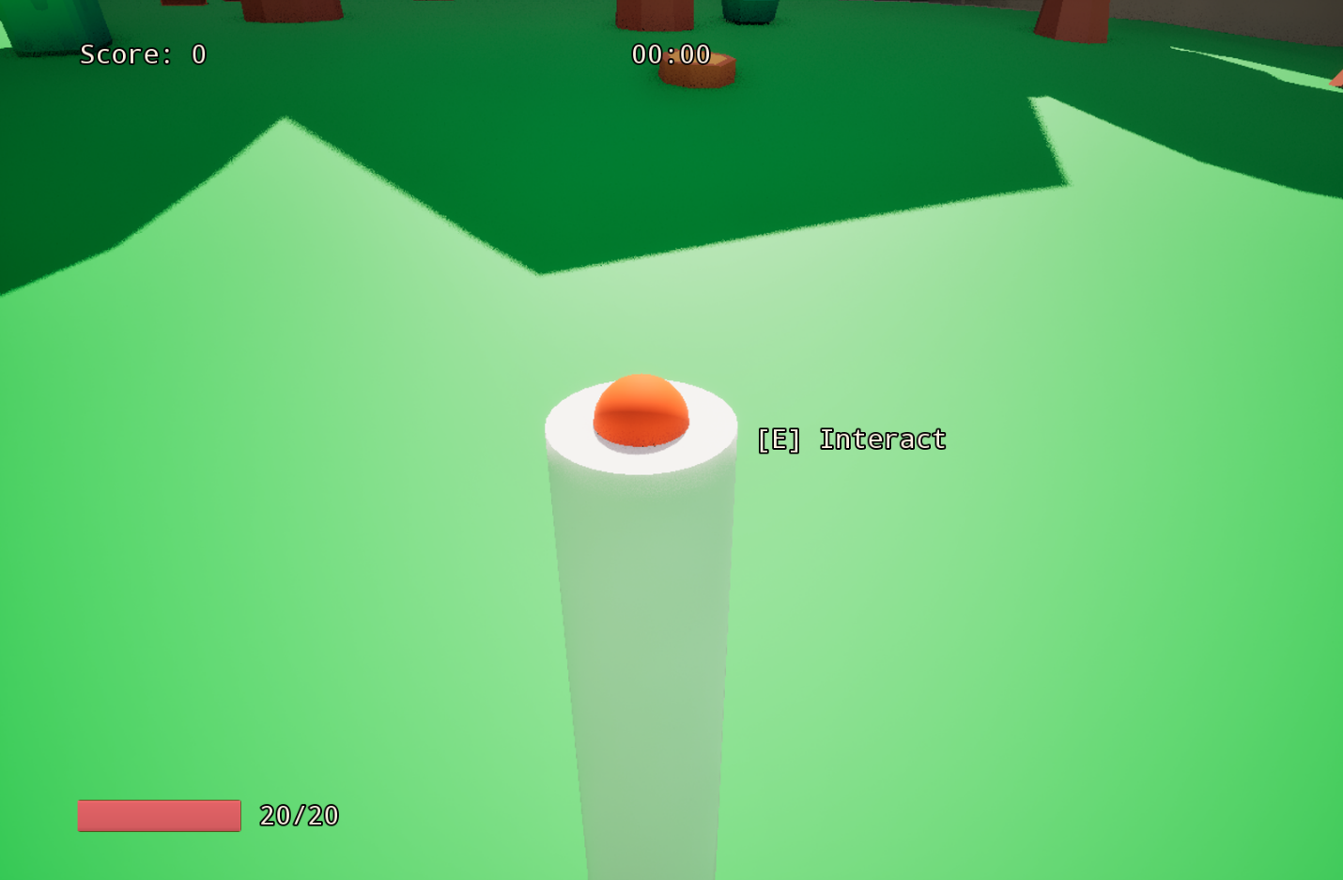

*Picture 3 Button to start the game, time and spawn of objects*

The score is displayed in the top-left corner of the screen and is updated based on the use of collected items.

There is a health bar (progress bar) anchored on the bottom-left, which is bound to division of players’ current life and their maximum life. These two numbers are also shown next to the health bar in the form of text, anchored to bottom-left corner, for better clarity.

There is a text showing availability of interaction in center of the screen (with small offset to the right). On the same place player can see a key that initiates interaction upon it being pressed (as seen in the picture 3). This text is hidden if there is no object in front of the player within the range of interaction.

Inventory, which is another widget, is also located in HUD. It’s anchored on the right- center of the screen and moved outside of the visible panel of HUD widget. Upon pressing “I” key, animation slides inventory from the right side of HUD widget onto the screen.

2,3. Inventory list and list entry widgets (WB_Inventory, WB_ItemListEntry)

The Inventory Widget consists of Border element and listview. Border element is used for setting up simple background and border for inventory.

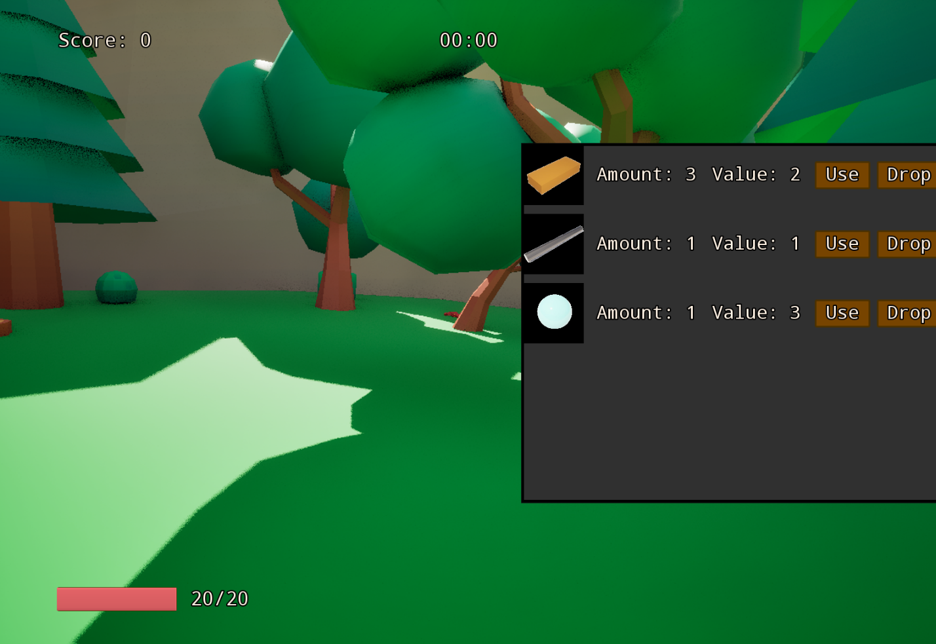

*Picture 4 Showcase of the player inventory*

Inventory is updated every time player picks up an item. Each item type has its own list entry. Each item entry has 5 elements:

- Icon: Image element which has its brush image variable bound to material interface from the item data object. Icon also holds the tooltip widget for item.

- Amount: Text that represents amount of picked up items of corresponding type.

- Value: Text that represents the value of single object of said type. This value is added to the score upon item usage.

- Use button: Once this button is pressed, single Item of chosen type is removed from game and score is adjusted.

- Drop button: Once this button is pressed, single item of chosen type is removed from inventory and spawned on the ground.

4. Item Tooltip widget (WB_ItemTooltip)

A simple tooltip is shown when player hovers over the icon of the item. Tooltip is built with the same style border as inventory and has two text elements in a vertical box. The top text element shows name of item and the bottom text shows additional information about the item.

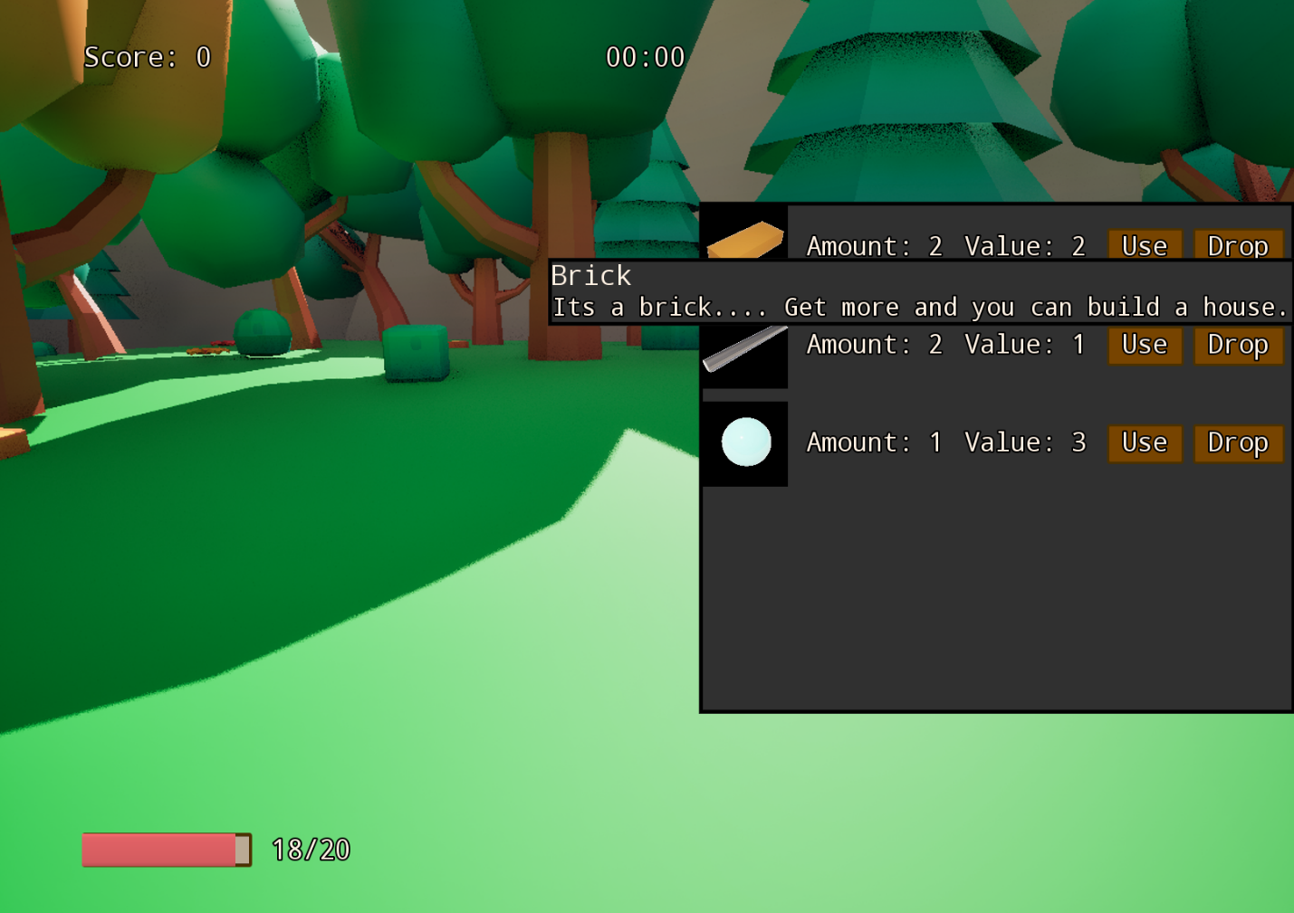

*Picture 5 Showcase of the tooltip functionality*

5. Pause menu widget (WB_GamePause)

This widget is shown in moment when player presses “Esc” or “P” keys. This menu is built similarly to the Main Menu. Pause Menu can be closed with the same key binds and by pressing the ‘Resume Game’ button.

Additionally from the ‘Main Menu’ screen this menu introduces two new information:

* Text for ‘Game time’ shows the whole timespan in which player has been within level.
* Text for ‘Last round time’ shows the amount of time that was required for player to finish last round (if there is this information).

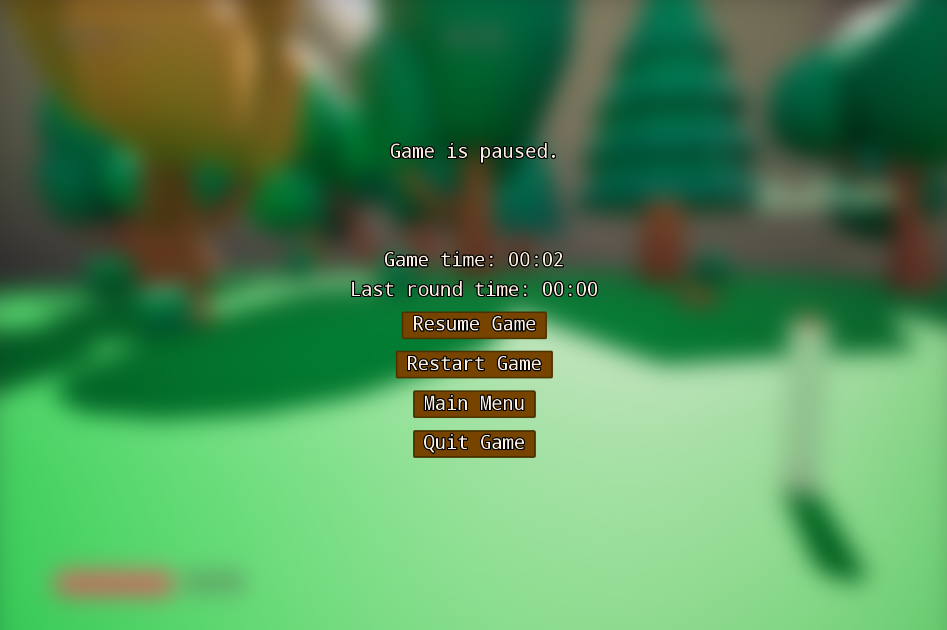

*Picture 6 Showcase of the Pause menu*

The adjusted Pause menu widget is also shown once player loses all their HP. Under that condition the pause menu widget has main text changed from ‘Game is paused.’ to ‘No life left.’ Additionally, the last round time will not be counted for the round in which player lost all their life and resume game options are unavailable by blocking the key bind for pause and hiding the ‘Resume Game’ button.

## Sources:

Button press sound effect - <https://pixabay.com/sound-effects/button-202966/>

Item pickup notification - <https://pixabay.com/sound-effects/notification-2-269292/>

Ambient background audio - <https://pixabay.com/sound-effects/summer-insects-243572/>

3D assets - <https://www.fab.com/listings/3dc642fe-69e4-407c-ac3f-d57ac6db2ede>